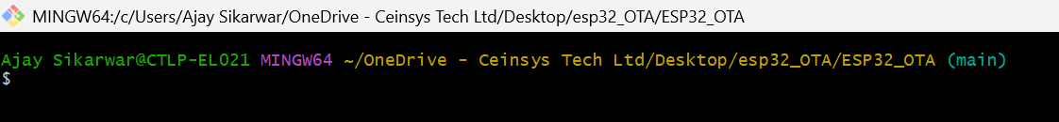

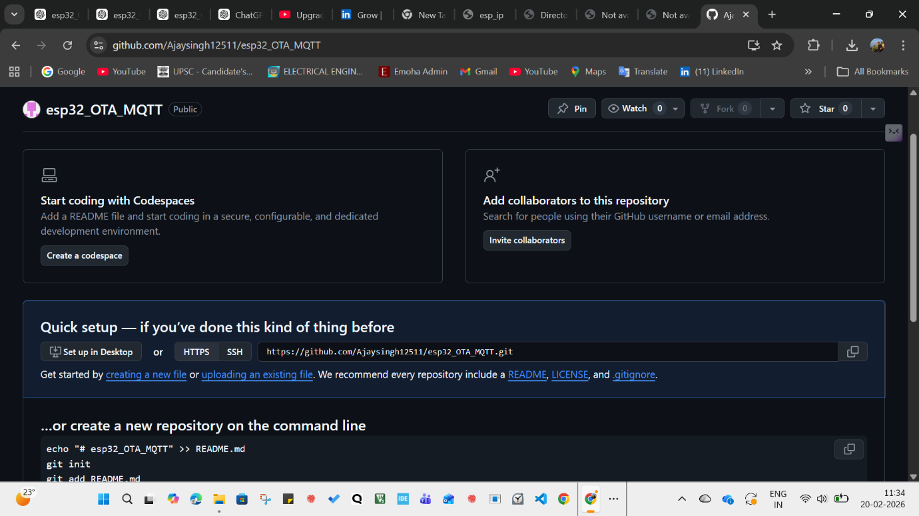
Repo:

1.Project Folder Me Jao
cd ~/OneDrive\ -\ Ceinsys\ Tech\ Ltd/Desktop/esp32_OTA/ESP32_OTA

2.Git Initialize Karo (Agar Pehle Nahi Kiya)
git init

3.Branch Name Set Karo
git branch -M main

4 Files Add Karo
git add .

5.First Commit Karo
git commit -m "Initial ESP32 OTA MQTT Project"
6. GitHub Pe New Repository Banao
Browser me jao:
👉 https://github.com/new
Repo name:
esp32_OTA_MQTT
Create repository.

7.Remote Add Karo
git remote add origin https://github.com/YOUR_USERNAME/esp32_OTA_MQTT.git
(Replace YOUR_USERNAME)
8. Push Karo
git push -u origin main
Check Remote
git remote -v
Future Me Update Push Karna Ho To
git add .
git commit -m "Update message"
git push

Agar Build Folder Accidentally Add Ho Gaya Ho
git rm -r --cached build
git commit -m "Removed build folder"
git push
